Butterfly Conservation: Importance, Challenges, and Strategies for Conservation in India

First Author – Shreya Baldua  
*Symbiosis Institute of Technology*Pune, India  
shreya.baldua.btech2021@sitpune.edu.in

Second Author – Suraqah Talal  
*Symbiosis Institute of Technology*Pune, India  
suraqah.talat.btech2021@sitpune.edu.in

Third Author – Ziaurrahman  
*Symbiosis Institute of Technology*Pune, India  
ziaurrahman.ziaurrahman.btech2021@sitpune.edu.in

Fourth Author – Sarthak Tripathi   
*Symbiosis Institute of Technology*Pune, India  
sarthak.tripathi.btech2021@sitpune.edu.in

*Abstract*— Focusing on the conservation of butterflies, this study addresses their vital role as pollinators, seed dispersers, prey, and predators within ecosystems. Butterflies have long captivated scientific exploration, artistic expression, and environmental concern, owing to their intriguing life cycles and their critical contribution to plant species diversity and ecological stability. However, the swift decline in floral landscapes and increasing pollution levels have led to the extinction of numerous butterfly species. Consequently, the need for butterfly conservation is underscored, with an exploration of diverse conservation strategies, including butterfly gardening, the establishment of protected areas and reserves, and comprehensive educational and outreach efforts. The research findings emphasize the urgent requirement for determined actions to ensure the sustained presence and thriving of butterflies within the intricate tapestry of ecosystems.

Keywords—Butterfly, Conservation, Wildlife

# INTRODUCTION

Insects make up for a significant part of planet earth’s biodiversity. These creatures make up the biological foundation of thriving ecological communities which depend on them as pollinators, seed dispersers, prey and predators. Butterflies, being one of the most taxonomically studied group of insects, although still containing many sparsely differentiated species. These captivating creatures of the animal kingdom have been the center of scientific research, artistry, and environmental concerns for a long time with a keen interest being on their astounding life cycle, involving the changes from egg to caterpillar to cocoon finally to an adult. As pollinators, they help countless plant species reproduce, ensuring the growth of fruits, vegetables, and flowers in the area. Additionally, they serve as important node links in food chain both as prey and predators. By serving as potential pollinators of their nectar plants as well as gauges of the condition and quality of both their host plants and the ecosystem as a whole, butterfly research is crucial to identifying and protecting potentially endangered habitats.

Recent years have seen a rapid loss of floral greenery owing to settlement advancements. Additionally, there has been a worrying increase in vehicle and industrial pollution in Indian metropolises. Butterflies, birds, and all of our other wildlife are rapidly vanishing due to the loss of greenery and rise in pollution. The end result is an ecosystem that is completely out of balance and the extinction of numerous species. Also seasonal changes, owing to climate changes constitute to endangerment of butterfly for the constant change of biological flora. Highest number of butterfly species are recorded during the post monsoon season after which the numbers dip through the year to the lowest during monsoon indicating a significant relationship of butterflies population to the local climate[1].

India houses approximately 1500 butterfly species, which is roughly 13% of the world’s known butterfly species. The country's diverse climate zones, altitudes, and ecosystems, which offer niches for a variety of flora, contribute to this astounding diversity. Some of these are endemic species, found nowhere else on the planet, adding to the importance for butterfly conservation needs.

Most natural ecosystems have been disturbed by human interventions and it has that has pressed on the need for environmental conservation to preserve them. More thorough research on the uncommon life of butterflies would pose a huge contribution towards this important area of biology, and help conservation of both local flora and fauna.

Although butterflies and their function as pollinators play a significant role in biodiversity, the value of their contribution has so far hardly been acknowledged in the management of their habitats. Resulting which, some species are in decline and may soon go extinct locally due to unsuitable habitat conditions, with human land use serving as the primary motivating factor in cultural landscapes.

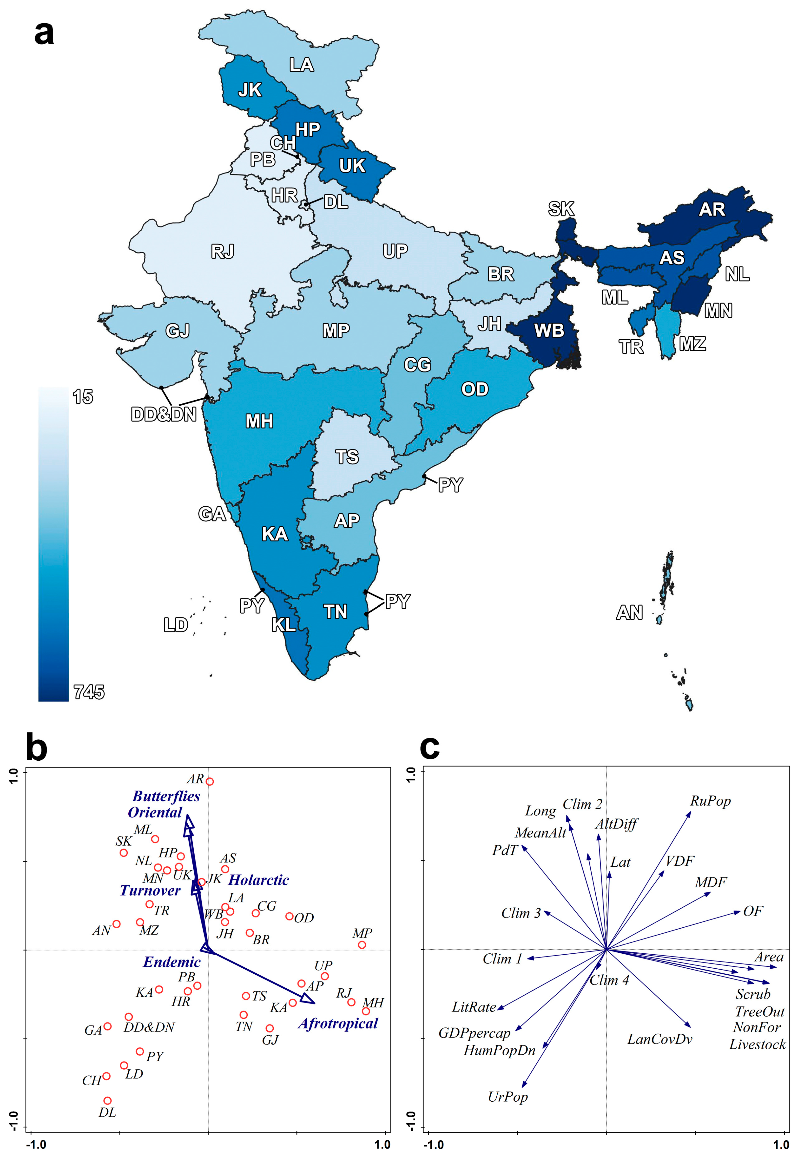

Figure 1. Map of Indian federal states, with state names, abbreviations and tone of blue indicating numbers of butterfly species.[2]

Due of their quick adaptation to environmental changes, butterflies provide ideal environmental health indicators. When compared to plants and animals, they are more sensitive to such changes. Their presence in a habitat has a direct impact on the local vegetation and habitat quality. In addition, butterflies are essential for pollination a variety of plant types. Some butterfly species migrate seasonally, showing a high level of biodiversity in their habitat. Butterfly populations, however, can drop due to things like deforestation, loss of nectar sources, habitat degradation, poaching, and forest fires, making them useful research subjects for biodiversity studies.

In order to effectively conserve butterflies, a novel and accurate model must be created, one that takes into account all of the life stages of the plants that serve as the larval feeding of butterflies, including seedling, juvenile, vegetative, reproductive, and dormant phases. To manage butterfly species as effectively as possible, case-by-case tailored conservation measures must be put into action.

# LITERATURE REVIEW

[3] **In situ conservation of butterflies throug establishment of butterfly gardens: A case study at Peechi, Kerala:** In this study, The KFRI campus's degraded forest area was selected. A number of butterfly habitats, including display areas, foraging areas, and host plants, were recreated.

The full potential of butterfly population growth and species diversity in butterfly gardens may be hampered by a lack of habitat area. Poor weather patterns during specific seasons can result in low butterfly populations. Particularly for monophagous species, host plant preferences may necessitate careful upkeep and habitat considerations in butterfly gardens.

[4] **Butterfly Species Diversity, Habitats and Seasonal Distribution in and Around Nagpur City, Central India:** The methods used included transect observations, field surveys, and butterfly identification. Comparisons with other cities were done while data on species richness, seasonal patterns, and habitat classification were gathered. The importance of conservation was emphasised by the documentation of new butterfly records.

The study discovered 145 butterfly species in Nagpur, with the monsoon and early winter being the two times of greatest abundance. Greater uniqueness was found in unaltered areas, highlighting the need for butterfly conservation in the city.

The study's limitations include a brief observation period, an emphasis on urban habitats that might overlook broader ecological context, and a dearth of information on sample size or in-depth statistical analyses, which may affect the reliability of the results.

[5] **The Wildlife (Protection) Act and conse prioritization of butterflies of the Wester Ghats, southwestern:** The paper studies about wildlife protection laws. Based on their status, habitat preferences, local distribution, and global and global distribution, butterflies are given conservation values according to the methodology. The Wildlife (Protection) Act schedules are then compared to these values to determine which species require better legal protection.

The article demonstrates how India's Wildlife (Protection) Act fails to adequately protect important butterfly species, particularly endemics and those in habitats that are in danger of extinction, and it makes the case for urgently updating and expanding the act's schedules.

Subjective evaluation of conservation values, a focus only on butterflies, and the assumption of successful Wildlife (Protection) Act changes without addressing implementation issues are some of the study's limitations.

[6] **Geography of Indian Butterflies: Patterns Revealed by Checklists of Federal States:** The article analyzed butterfly species distribution patterns in Indian federal states using checklists, geographic analysis, climate, land cover, socioeconomic analysis, and statistical modelling.

According to the study, geography, climate, land cover, and socioeconomic factors have an impact on the increase in butterfly species richness in northeastern India, with high endemism in southern mountain states.

The study is limited by potential data inaccuracies, oversimplified models, and a restricted geographic focus within India, which prevents it from gaining insights into ecological mechanisms and temporal variations.

# METHODOLOGY

## Habitat Restoration and Management

Habitat Restoration and Management are fundamental conservation techniques aimed for reviving and protecting the natural habits of any and all fauna. This approach involves methods to develop new habitats and restore the old existing ones. Worked on the improvement of conditions to sustain local butterfly species and working on the factors causing habitat degradation. This process involves plantation of native plants, pertaining to the critical local habitats, reducing invasive species and wildlife disturbances. This is a long term process that aims to improve the overall quality of the ecosystem by improving the local flora and fauna and promote biodiversity.

## Butterfly Gardening

Butterfly gardening entails the deliberate cultivation of gardens with specifically selected plant species tailored to cater the ecological needs of butterflies. These gardens act as vital sanctuaries, supporting all the various life stages of butterflies and ensuring a reliable food supply. These are established such gardens in diverse settings to attract and sustain local butterfly populations. The selection of native plant species is critical to cater to the preferences of indigenous butterfly species.

## Protected Areas and Reserves

The establishment and upkeep of protected areas and reserves play a vital role in preserving crucial butterfly habitats and other important flora and fauna. These designated zones, which encompass national parks, wildlife sanctuaries, and conservation reserves, serve as secure refuges for butterflies and other fauna. Governments and conservation entities are responsible for creating and overseeing these protected areas, focusing on butterfly conservation. These areas typically enforce laws that restrict human activities that might potentially harm the normal functioning of local wildlife.

## Education and Outreach

Promoting awareness and educating the public regarding the significance of butterflies and their habitats is essential for mobilizing support for conservation endeavors. Conservationists and organizations conduct public outreach activities, including workshops, educational programs, and awareness campaigns. These initiatives are designed to impart knowledge about butterflies' roles within ecosystems and advocate for sustainable practices. A pivotal approach to educating people is through news articles, or more likely social media in the modern era. Web Dashboard development has been used to visualize and present the research to people over their local devices to promote the efforts of propagating the message.

## Research and Monitoring

Continuous research plays a pivotal role in comprehending butterfly populations, their behaviors, and the factors influencing them. Monitoring initiatives diligently observe population trends, aiding in the identification of conservation priorities. Scientists and conservation practitioners engage in field studies, data collection pertaining to butterfly populations, and employ methods like mark and recapture to monitor individual butterflies. The insights gathered from such endeavors serve as crucial inputs for shaping conservation strategies.

## Climate Change Adaption

One of the biggest environmental threats of the modern era is climate change, and its profound impact affecting ecosystems, species, and habitats worldwide. Butterflies are particularly susceptible to these changes because they are temperature-sensitive ectothermic organisms. Their distribution, behavior, and life cycles are all affected by climate change, which makes conservation extremely difficult. Strategies for protecting butterflies from climate change emphasize assisting these delicate insects in adjusting to changing environmental conditions.

# RESULT & DISCUSSION

The methodology employed to conserve butterflies and bolster their populations through awareness campaigns as articles or web dashboards, butterfly garden establishment yielded consistent and encouraging results. The creation of butterfly habitats and the introduction of appropriate host plants consistently leads to substantial increases in butterfly populations and species diversity. Notably, these gardens support the presence of both endemic species from the Western Ghats and those protected under the Indian Wildlife Act. Weather conditions, particularly temperature and humidity levels, emerged as influential factors in butterfly occurrence patterns. In urban and suburban areas, the establishment of butterfly gardens consistently enhances butterfly diversity and abundance, making a meaningful contribution to broader species conservation efforts.

# CONCLUSION

Our research underscores the critical importance of butterfly conservation in restoring ecological balance and preserving imperiled ecosystems, particularly in the face of challenges such as habitat loss and escalating pollution in urban areas of India. The decline of butterfly populations and the looming threat of species extinction necessitate a focused approach. This study highlights the need for in-depth butterfly research to identify and protect vulnerable habitats, along with the establishment of butterfly-friendly environments through the introduction of suitable host plants, creation of protected zones, and reserves dedicated to their preservation. Complementing these efforts are educational initiatives, outreach programs, continuous research, and vigilant monitoring to enhance public awareness and understanding of butterfly populations and their intricate behaviors.

Additionally, we emphasize the development and implementation of strategies to shield butterflies from the impacts of climate change, ensuring their resilience in changing environmental conditions. In summary, our research underscores the vital role of butterfly conservation, as these delicate insects serve as crucial pollinators and integral contributors to biodiversity. Dedication to these conservation endeavors is imperative to secure their survival and promote their thriving presence within our ecosystems.

##### References

1. Nair, Aiswarya V., Pradarsika Mitra, and S. A. Bandyopadhyay. "Studies on the diversity and abundance of butterfly (Lepidoptera: Rhopalocera) fauna in and around Sarojini Naidu college campus, Kolkata, West Bengal, India." Journal of Entomology and Zoology Studies 2.4 (2014): 129-134.
2. Das, G.N.; Fric, Z.F.; Panthee, S.; Irungbam, J.S.; Konvicka, M. Geography of Indian Butterflies: Patterns Revealed by Checklists of Federal States. Insects 2023, 14, 549. <https://doi.org/10.3390/insects14060549>
3. Mathew, George, and Mary Anto. “In Situ Conservation of Butterflies through Establishment of Butterfly Gardens: A Case Study at Peechi, Kerala, India.” Current Science, vol. 93, no. 3, 2007, pp. 337–47. JSTOR, [http://www.jstor.org/stable/24099464. Accessed 24 Sept. 2023](http://www.jstor.org/stable/24099464.%20Accessed%2024%20Sept.%202023).
4. Tiple, Ashish D., and Arun M. Khurad. "Butterfly species diversity, habitats and seasonal distribution in and around Nagpur City, central India." World Journal of Zoology 4.3 (2009): 153-162.
5. Kunte, Krushnamegh. “The Wildlife (Protection) Act and Conservation Prioritization of Butterflies of the Western Ghats, Southwestern India.” Current Science, vol. 94, no. 6, 2008, pp. 729–35. JSTOR, http://www.jstor.org/stable/24100626. Accessed 24 Sept. 2023.
6. Kunte, Krushnamegh, et al. “Patterns of Butterfly, Bird and Tree Diversity in the Western Ghats.” Current Science, vol. 77, no. 4, 1999, pp. 577–86. JSTOR, http://www.jstor.org/stable/24102886. Accessed 24 Sept. 2023.